MONYETLA BURSARY PROJECT – 09 MAY 2026
LIFE SCIENCES THE HUMAN EYE
PAST PAPER QUESTIONS

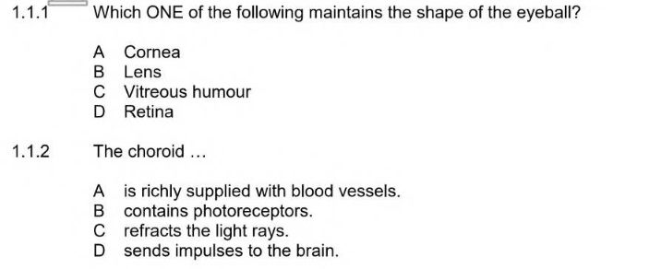
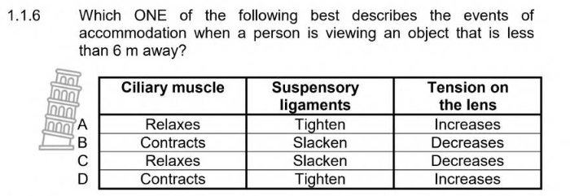
ANSWERS
    - C
    - A
1.1.6 B 3 x 2 (6)

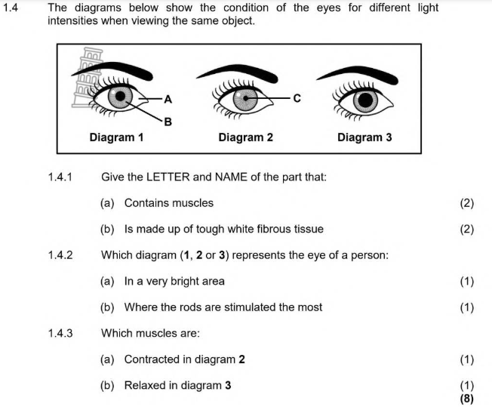

ANSWERS
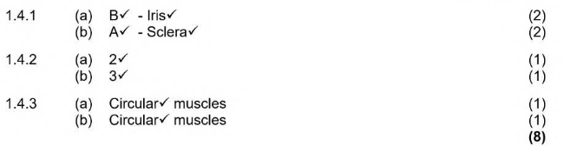
NSC – Paper 1 (November 2018)
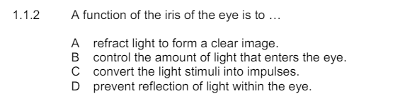
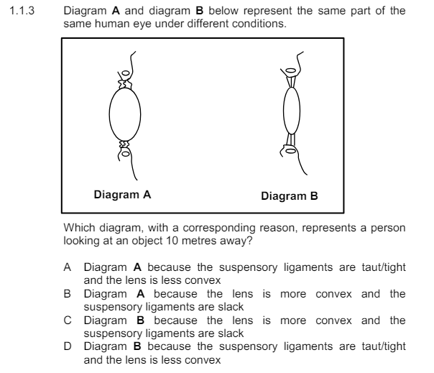
ANSWERS
1.1.2 B
    - D 2 x 2 (4)

NSC – Paper 1 (November 2016)
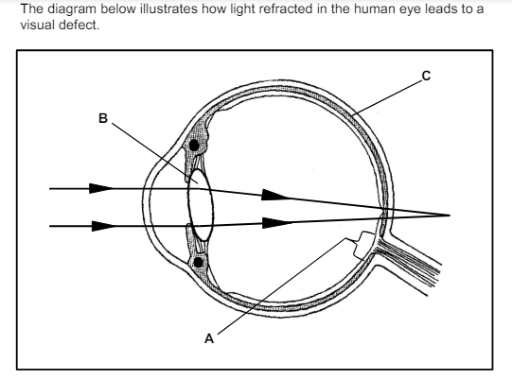

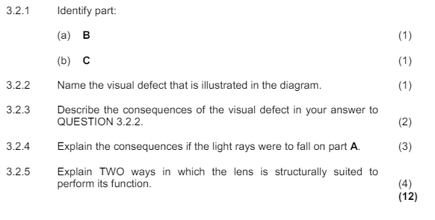
ANSWERS

